Working title: Feature-based Attention and Reward: Insights from Steady-state Visually Evoked Potentials

Ivan Grahek1☨*, Antonio Schettino1,2☨, Gilles Pourtois1, Ernst H.W. Koster1,

& Søren K. Andersen3

1. *Department of Experimental Clinical and Health Psychology, Ghent University, Henri Dunantlaan 2, B-9000, Ghent, Belgium*
2. *Institute for Globally Distributed Open Research and Education (IGDORE)*
3. *School of Psychology, University of Aberdeen, William Guild Building, Aberdeen, AB24 3FX, United Kingdom*

# Abstract

Selective attention is thought to prioritize object features related to high rewards by increasing their saliency and decreasing the saliency of other features. This mechanism is proposed to be linked to the activity of the visual cortex. Electrophysiological studies have provided support for this account, but have focused on transient attention and neural activity when either high- or low-rewarded feature is present. In this study, we investigated the influence of reward presence and magnitude on the allocation of sustained feature-based attention using steady-state visual evoked potentials (SSVEPs). SSVEPs represent oscillatory responses of the visual cortex and allow for tracking of simultaneous allocation of attention toward multiple features. We recorded EEG in 40 participants while they completed the Random Dot Kinematogram task. Dots of two colors were tagged with different frequencies. On each trial, participants were instructed to attend one of the colors and detect coherent movements. After the first block (baseline), participants were informed that they could earn rewards (training), and that the two colors were paired with high or low probability of earning a reward. In the third block (test) participants could not earn any rewards. Participants were faster and more accurate in the training and test blocks compared to baseline. No effect of reward magnitude on behavior was found. SSVEP amplitudes were increased for attended compared to unattended color. The amplitudes were decreased in training compared to baseline and test blocks. While the amplitude of the high-reward color remained the same across the blocks, the amplitude of the low-reward color was reduced in the training block. These results provide first evidence that SSVEPs can be used to detect the influence of rewards on feature-based sustained attention. Also, they provide an insight into the dynamics and trade-offs related to processing of features linked to different reward magnitudes.

Keywords: attention; EEG; feature-based attention; reward; motivation; steady-state visually evoked potentials; frequency tagging

# Introduction

Given the limited processing capacity, selective attention is crucial in choosing which stimuli will be processed (Chun, Golomb, & Turk-Browne, 2011; Desimone & Duncan, 1995). Visual selective attention (VSA) prioritizes stimuli in accordance with current goals and knowledge based on previous learning (Chelazzi, Perlato, Santandrea, & Della Libera, 2013). Della Libera and Chelazzi were the first to show that objects related with high rewards are easier to select as targets and harder to ignore as distractors, while the opposite is true for objects related to low rewards (Della Libera & Chelazzi, 2009).

“Alternative formulation: humans are more efficient to select targets associated with high rewards, but relatively inefficient at ignoring them when they are shown as distractors. Interestingly, the ability to ignore a given distractor also improved when this was consistently followed by high (as opposed to low) rewards, whereas the ability to select the same items as targets became relatively impaired.” “In summary, the present results provide evidence that reward has a direct impact on human vision that is independent of its role in strategy and endogenous attentional set. Our results suggest that the anterior cingulate cortex—a cortical expression of the mesolimbic dopamine system—plays a crucial role in this source of attentional control.”

Similar results were also found for features and locations related to different reward contingencies (for recent reviews see: Anderson, 2016; Failing and Theeuwes, 2017). The mechanisms through which rewards influence selective attention are a matter of intensive empirical and theoretical work. However, most researchers in the field agree that rewarded locations, objects, and object features are prioritized by increasing their saliency, while the saliency of the other locations, objects, and object features is reduced. This mechanism is commonly linked to the activity of the neurons in the visual cortex (Roelfsema, van Ooyen, & Watanabe, 2010). This idea has received a significant amount of support in fMRI and ERP studies.

It is known that there is a bottom-up effect, but here we wanted to look at what happens when participants strategically change their attentional set.

**Hickey & van Peelen, 2017**

When reward is linked to a discrete category, for example, if detecting “people”’ in a scene always results in high-magnitude reward, then humans and other animals will look out for these objects and this involves the establishment of top-down attentional set. Attentional set changes how stimuli are encoded and, though interesting in its own right, this effect is theoretically distinct from the direct, low-level, and nonstrategic impact of reward feedback on already-encoded representations that is the focus of the current study (Hickey et al., 2010a; Maunsell, 2004).

Most of the human behavioral and neural data supporting the idea of facilitation of reward-related stimuli and suppression of other stimuli comes from cueing and visual search tasks. When it comes to feature-based attention, most of the work is based on visual search paradigms in which different features present in briefly presented search arrays are related to different reward contingencies. This approach has been useful for mapping brain responses to transient stimuli related to different reward schedules. However, these designs carry several problems. First, given that different features appear in different locations in the search array, it is hard to disentangle the contribution of feature-based from the contribution of spatial attention to the reward effects on attention. Second, these paradigms allow for investigating only transient effects of reward on attention, while there is no possibility of investigating more sustained allocation of attention towards certain features. Finally, these paradigms do not allow for simultaneous measurements of attention allocation towards stimuli related to different values.

Recording steady-state visually-evoked potentials (SSVEPs) offers possibilities to overcome these issues. SSVEPs represent oscillatory responses of the visual cortex that have the same frequency as the driving visual stimulus (Norcia, Appelbaum, Ales, Cottereau, & Rossion, 2015). They are generated by the primary visual cortex (V1-V3)[REF]. SSVEPs allow for the study of simultaneous allocation of selective attention towards multiple stimuli. Each of those stimuli can be flickering at different frequencies which will produce SSVEPs at those respective frequencies. SSVEPs have been particularly useful in the study of attention because the amplitude of SSVEPs is reliably increased by spatial and feature-based attention (Andersen, Müller, & Hillyard, 2012). The application of SSVEPs has allowed for a clear experimental dissociation between spatial and feature-based selective attention (Muller et al., 2006) and for tracking the time-course of feature-based attention (Andersen & Müller, 2010). To summarize, SSVEPs provide a signal of good signal-to-noise ratio which enables: tracking simultaneous allocation of attention across multiple stimuli of different features; provide a measure of sustained attention; and can dissociate between spatial and feature-based attention.

In the present study we aimed to better understand the influence of rewards on feature-based selective attention by simultaneously looking into the amount of attention allocated towards stimuli linked to high and low reward probabilities. We recorded the SSVEPs in conditions when participants attended colors linked to either high or low reward probabilities. This allowed for making a clear distinction between the effect of attention and the effect of reward magnitude. Finally, our experiment consisted out of three phases (baseline, acquisition, and extinction) that allowed us to investigate the influence of reward probability on attention when rewards are present, but also when they are no longer relevant.

**Andersen et al., 2012**

“In typical visual search paradigms, each element of the search display is presented at a unique location, and hence spatial locations and features are confounded”

SSVEPs scale with the amount of attention: Toffanin, P., de Jong, R., Johnson, A., & Martens, S. (2009). Using frequency tagging to quantify attentional deployment in a visual divided attention task. International Journal of Psychophysiology, 72(3), 289-298.

**Norcia et al., 2015**

*Advantages of SSVEPs*

“The SSVEP is particularly well suited to attention research questions, as it provides a high-SNR measure of neural activity that can be unambiguously associated with specific external stimuli, even when multiple stimuli are present at the same time. Importantly, it allows monitoring of responses made to stimuli that are outside of the focus of attention, something that is difficult to do with behavioral methods. Moreover, the SSVEP can be flexibly deployed over a number of configurations, including the tagging of both spatially distinct and spatially overlapping stimuli. In light of these attributes, the SSVEP approach has gained possibly its greatest utility in studies that have addressed the cognitive and neural mechanisms underlying volitional attention in human beings.”

*Dissociating spatial and feature attention*

“The multi-input SSVEP studies already discussed provide compelling evidence that volitional attention operates on spatially distinct regions of a scene to modulate neural processing in an adaptive, goal oriented manner. Ample evidence also exists that attention can operate in a nonspatial manner to enhance processing of particular visual features such as color, orientation, or direction of motion. Because the SSVEP can be obtained from multiple overlapping stimuli, this method has been particularly useful in elucidating the neural mechanisms underlying such feature-based attention.

“Beginning in 2006, Muller, Andersen, and Hillyard conducted a series of elegant studies aimed at dissociating the influence of attention to features and feature conjunctions from the influence of spatial attention. These studies utilized overlapping fields of randomly moving red and blue colored (or in some cases achromatic) dots that were modulated at distinct frequencies (Figure 15).”

*Attended vs. unattended advantage*

“Frequency tagging makes it possible to monitor the response to multiple stimuli that are simultaneously visible. This feature of the SSVEP makes it possible to measure the effects of allocating attention to spatial location even for stimuli that are outside of the focus of conscious attention. In the first application of the SSVEP to spatial attention (Morgan, Hansen, & Hillyard, 1996), two strings of alphanumeric characters were presented in the left and right visual hemifields

(Figure 13).”

**Soren chapter**

“SSVEPs allow us to register continuously the neuronal processes underlying the perception of each individual element in search displays (Soren chapter)”. “A number of studies have localized the major generators of the SSVEP to early visual cortical areas and the highest SSVEP amplitudes are commonly recorded at occipital and parietal electrodes. The specific cortical areas involved and their individual contributions to the total scalp-recorded signal appear to depend upon the driving frequency. For the SSVEP elicited by a pattern-reversing stimulus, which produces a percept of motion, combined SSVEP and fMRI recordings have identified early visual areas V1 (primary visual cortex) and the motion sensitive MT/V5 as the main generator sources with minor contributions from midoccipital (V3a) and ventral occipital (V4) areas.” In the PNAS paper: “the cortical currents giving rise to the SSVEP attention effect were localized to a region containing the early visual areas V1-V3.”

*Chelazzi 2013*

“When performance is considered determinant for the achievement of rewards, then plasticity is observed at the level of the specific processes that enabled it (i.e., target selection and distracter inhibition), and learning takes the form of an instrumental type of adaptation (Della Libera & Chelazzi, 2009). Differently, when rewards are viewed as random, fortuitous events, then a direct and passive association takes place between the perceived stimuli and the rewards that follow them (Della Libera, Perlato, & Chelazzi, 2011).”

“Recent research suggests that both types of reward-based attentional learning involve brain structures usually associated with attentional control, including posterior parietal cortex (Krebs et al., 2011; Peck et al., 2009), and the processing of rewarding information, including the striatum and the anterior cingulate cortex (Hickey, Chelazzi, & Theeuwes, 2010a; O’Doherty, 2004; Schultz, 2006; Weil et al., 2010). Moreover, and perhaps most interestingly, they can affect the neural representation of visual stimuli at the level of extrastriate visual cortex, including area V4 and the inferotemporal cortex (Frankó, Seitz, & Vogels, 2010; Hickey, Chelazzi, & Theeuwes, 2010a; Jagadeesh et al., 2001; Mogami & Tanaka, 2006; Pessiglione et al., 2008; Weil et al., 2010), and this can occur even outside the context of a task as the result of the shear association of a stimulus with reward (Frankó, Seitz, & Vogels, 2010)”

“To sum up, the studies on attentional processing of stimuli associated with biased rewards reveal that when highly rewarded stimuli are task relevant they may lead to faster and more accurate performance in visual search tasks (Della Libera & Chelazzi, 2009; Kristjánsson, Sigurjónsdóttir, & Driver, 2010), and in the Stroop task (Krebs, Boehler, & Woldorff, 2010; Krebs et al., 2011); they also engender stronger inter-trial priming effects (Hickey, Chelazzi, & Theeuwes, 2010a; Kristjánsson, Sigurjónsdóttir, & Driver, 2010) and a higher resistance to the attentional blink phenomenon (Raymond & O’Brien, 2009). When the same stimuli act as distracters that need to be ignored they often lead to stronger effects of involuntary attentional capture (Anderson, Laurent, & Yantis, 2011a, 2011b; Rutherford, O’Brien, & Raymond, 2010) and greater interference effects (Della Libera & Chelazzi, 2009; Krebs, Boehler, & Woldorff, 2010; Krebs et al., 2011). However, it should be recalled that while some of the above results could all be reconciled with the notion of value learning, and the ensuing influence on attentional priority, some other results require a different explanation, namely one where rewards cannot only increase the salience of certain visual stimuli, thus facilitating their selection, but also increase the efficiency with which other stimuli can be suppressed. We have proposed that the latter effects can only be accounted for by making reference to notions of instrumental conditioning, whereby the delivery of rewards in relation to the suppression of a certain stimulus will reinforce the tendency for attention mechanisms to suppress the same stimulus on future occasions, not unlike the influence of instrumental conditioning on motor performance.”

We show that:

1) Introduction of rewards affects feature-based attention both behaviorally and in SSVEPs

2) Leads to lower levels of attention for the low rewarded stimuli, while high rewarded stimuli stay at the same level

3) The lingering effect of reward is present in the absence of rewards, even though our measure of feature-based attention goes back to baseline

**Maunsell, 2004**

However, the few neurophysiological studies that have varied the difficulty of a spatial attention task have shown that neuronal modulations by attention vary depending on task demands [29,30,34].

**SSVEPs**

**The present study**

Our goal is to use SSVEPs in order to, for the first time, assess the influence of reward magnitude on sustained feature-based attention. How this fits with the theoretical models presented in the first part of the intro? Present the main idea and design of the study. We manipulate reward probability, not magnitude (Maunsell, 2004).

In order to better understand the underlying neural substrates of reward-guided deployment of attention in relation to depressive symptoms, we have decided to add an EEG study to our project. This study is focusing on the steady state visually evoked potentials (SSVEPs) which represent the oscillatory responses of the visual cortex to flickering stimuli (Norcia, Appelbaum, Ales, Cottereau, & Rossion, 2015). This method has already been successfully used to explore the “attention grabbing” by irrelevant emotional stimuli (Attar, Andersen, & Müller, 2010) and is particularly interesting because it provides not just a measure of which stimuli capture attention, but also a continuous measure of how much attention is simultaneously being paid towards different stimuli. The first aim of this study is to investigate the possibility of using the SSVEPs to detect differences in the amount of attention deployed towards stimuli based on their associated reward value (Study 2a). The second aim of this study is to explore if the amount of attention being paid towards reward-related stimuli is linked to depression levels and anhedonic symptoms in particular (Study 2b).

# Methods

## Participants

We tested 48 participants with normal or corrected-to-normal vision and no history of psychiatric or neurological disorders. Due to technical problems (4) or excessive artifacts (4) in the EEG recordings, 8 participants were excluded. Thus, the final data set consisted out of 40 participants (XX female; median age). Participants received 20€ plus up to 6€ extra as monetary rewards (on average 25,5€). The study was approved by the ethics committee of Ghent University.

## Stimuli and task

We used the Random Dot Kinematogram (RDK) task (Andersen & Müller, 2010) in which participants were presented with two overlapping circular RDKs of isoluminant colors (red and blue) on grey background. Viewing distance was fixed with a chinrest to 80cm from the 21-inch CRT screen (1024 X 768 and 120 Hz refresh rate). The two RDKs consisted out of 125 randomly and independently moving dots (size and visual angle). The size of the cloud was XXX degrees of visual angle. Each RDK was flickering at a different frequency (10 or 12Hz). The mapping between color and frequency was counterbalanced across participants. On one third of trials most of the dots (75%) moved coherently in one of the RDKs [check if this percentage is in the attended or in both] (up, down, left, or right). Participants’ task was to detect the coherent movement as fast as possible by pressing the space key on keyboard. Response time was limited to 1500ms. At the beginning of each trial, participants were instructed by a verbal audio cue (“red” vs. “blue”) which of the two RDKs to attend. Each trial could contain zero, one, two, or three coherent movements. Correct responses were followed by a tone (sine wave of either 800 or 1200Hz 1000 ms long, counterbalanced across participants). Responses that were too late or incorrect were followed by a 1s square wave tone of 400Hz.

The experiment started with 4 practice blocks of 60 trials. After each block participants received feedback on their performance (percentage of correctly detected movements and percentage of correct responses). After finishing the practice phase participants completed 12 blocks of the experiment divided into 3 phases. The first phase was the baseline in which participants were doing the described task. In the second phase the task was the same, but participants were instructed that they can earn additional monetary rewards (up to 6€) based on their performance. They were instructed that one of the colors is paired with high probability (80%) and the other color is paired with low probability (20%) of earning 10 extra cents for each correct detection. The receipt of the reward was signaled by a new tone that replaced the usual correct tone. If the correct tone was a sine wave of 800Hz the reward tone was a sine wave of 1200Hz and vice versa. At the end of each of the 4 blocks of the reward phase participants got feedback on their performance and feedback on the amount of extra money earned within the block. The third phase was the extinction phase that was the same as baseline and participants could not earn any monetary rewards. The whole task lasted for approximately (including EEG preparation the participants were in the lab for 1:45 hours; optional: the task lasted for about 50 minutes) and participants were encouraged to take brakes in between the blocks. Upon completing the task, participants filled-in two questionnaires in order to measure reward sensitivity (BIS-BAS; Franken et al., 2005) and depression levels (BDI-II; Van der Does, 2002).

## Pre-processing of the behavioral data

* We have discarded RTs below 200ms (0%) and the upper limit within the task was 1000ms (check this in the Matlab script) so that no RTs were above that.

## EEG recording and pre-processing

Electroencephalographic activity (EEG) was recorded with an ActiveTwo amplifier (BioSemi, Inc., The Netherlands) at a sampling rate of 512 Hz and online band-pass filtered at 0.016 – 100 Hz. Sixty-four Ag/AgCl electrodes were fitted into an elastic cap, following the international 10/10 system. The common mode sense (CMS) active electrode and the driven right leg (DRL) passive electrode were used as reference and ground electrodes, respectively. Additional external electrodes were applied to the left and right mastoids, as well as on the outer canthi of each eye and in the inferior and superior areas of the left orbit (to record horizontal and vertical electrooculogram, EOG).

Data pre-processing was performed offline with custom MATLAB scripts and functions included in EEGLAB v14.1.1b. After subtracting the mean value of the signal (DC offset), the continuous EEG data were epoched between 0 and 3,250 ms, corresponding to the beginning and end of the RDK trial, respectively. After referencing to *Cz*, FASTER v1.2.3b was used for artifact identification and rejection using the following settings: (i) over the whole EEG signal, channels with variance, mean correlation, and Hurst exponent exceeding *z* = ±3 were interpolated via a spherical spline procedure; (ii) the mean across channels was computed for each epoch and, if amplitude range, variance, and channel deviation exceeded *z* = ±3, the whole epoch was removed; (iii) within each epoch, channels with variance, median gradient, amplitude range, and channel deviation exceeding *z* = ±3 were interpolated; (iv) grand-averages with amplitude range, variance, channel deviation, and maximum EOG value exceeding *z* = ±3 were removed; (v) epochs containing more than 12 interpolated channels were discarded. All remaining epochs were scanned with SCADS and rejected when flagged as artefactual. For details, see our commented code at <https://osf.io/xxxxx/>. After pre-processing, the average number of interpolated channels was 4.08 (*SD* = 1.75, range 0 – 7) and the mean percentage of rejected epochs was 9.74% (*SD* = 6.77, range 0 – 32.50; similar rejection rate across conditions). After re-referencing to averaged mastoids, trials in each condition were averaged separately for each participant, resulting in the following grand-averages: (i) baseline, red attended; (ii) baseline, blue attended; (iii) acquisition, red attended; (iv) acquisition, blue attended; (v) extinction, red attended; (vi) extinction, blue attended.

Electrodes with maximum ssVEP amplitudes were identified by calculating isocontour voltage maps based on grand-averaged data collapsed across all conditions. As shown in *Figure 2*, activity was mainly localized at central occipital channels (i.e., Oz, POz, O2, PO3). To account for inter-individual variations in topographical ssVEP amplitude distributions, we identified and averaged activity from the four electrodes displaying, for each participant, the largest frequency-specific amplitude. After removing linear trends, we extracted ssVEP amplitude at 10 and 12 Hz from each individual electrode cluster, separately for each condition (averaged across trials). Fast Fourier Transforms on the EEG signal in a time window from 500 ms (to exclude the typically strong phasic visual evoked response to picture onset) to 3,250 ms after stimulus onset was applied, and amplitudes were obtained by extracting the absolute values of the resulting complex Fourier coefficients.

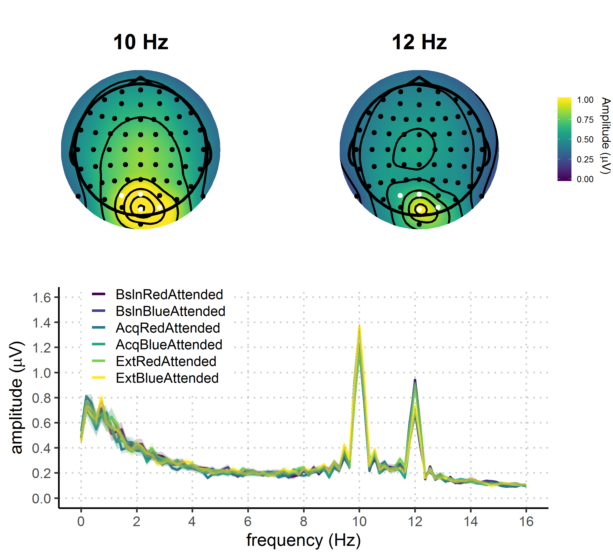

**Figure 2.** Grand average FFT-amplitude spectra derived from EEG signals at each participant's best four-electrode cluster for the 10 and 12 Hz signal.

## Statistical analyses

Behavioral and EEG data were analyzed using bayesian multilevel regressions (do we want to motivate the use of the bayesian approach?). We fitted and compared multiple models of varying complexity to predict hit rates, reaction times, and SSVEP amplitudes. Each of the fitted models contained both constant and varying effects (also known as fixed and random). Both EEG signal and behavioral performance are known to be dependent upon participant-specific characteristic (e.g., skull thinness, skin conductance, and hair; speed of responding etc.) therefore we decided to model this variability by adding varying intercepts in our models. Additionally, the studied effects are also known to vary in magnitude over participants (e.g., reward sensitivity and selective attention) and this is why we opted for including varying slopes in our models. The models were fitted using the R package *brms* (Bürkner, 2016) that employs the probabilistic programming language *Stan* (Carpenter et al., 2016)to implement Markov Chain Monte Carlo (MCMC) algorithms in order to estimate posterior distributions of the parameters of interest. Each of the models was fitted using weakly regularizing prior distributions (default priors in *brms* were used) and Gaussian likelihood. Four MCMC simulations (“chains”) with 10000 iterations (2000 warmup) and a thinning interval of 1 were run to estimate parameters in each of the fitted models. Further analyses were done following the recommendations for Bayesian multilevel modeling using *brms* (Nalborczyk et al., 2018). We have confirmed that all of the models have converged well by examining the trace plots (which can be found at: XXX), autocorrelation, and the variance between chains (Gelman-Rubin statistic; Gelman & Rubin, 1992). We compared models based on their fit to the actual data using the Bayesian *R*2 (Gelman, Goodrich, Gabry, & Ali, 2017), and their out-of-sample predictive performance using the Widely Applicable Information Criterion (WAIC; Watanabe, 2010). The best model was selected and the posterior distribution of parameters and conditions of interest was examined. Differences between conditions of interest were assessed by computing the mean and the 95% highest density interval (HDI) of the difference distribution between posterior distributions of the respective conditions (Kruschke, 2014).

# Results

## Behavioral results

We fitted three models to predict both hit rates and reaction times separately. First we fitted the *Null model* with no constant effects and varying intercepts across subject. This model was fitted in order to investigate the possibility that the data is best explained just random by variation between subjects. In order to investigate the effect of phase we fitted the *Reward phase model* that included only reward phase as the constant predictor and varying intercepts and slopes across subjects for this effect. To investigate the possible interaction between reward phase and reward magnitude, we fitted the *Interaction model* with these two effects and their interaction as constant effects. The intercepts and slopes of main effects and their interaction were allowed to vary across participants. It is important to note there that there are two additional models that, although possible to fit, do not make sense in the context of our experiment. The model with only the effect of reward magnitude overlooks the fact that this effect will necessarily be most pronounced in the acquisition phase, thus interacting with the effect of reward phase. The same logic applies to the model with additive effects of reward phase and magnitude.

## Hit rates

Average hit rates were XXX (Figure 3)

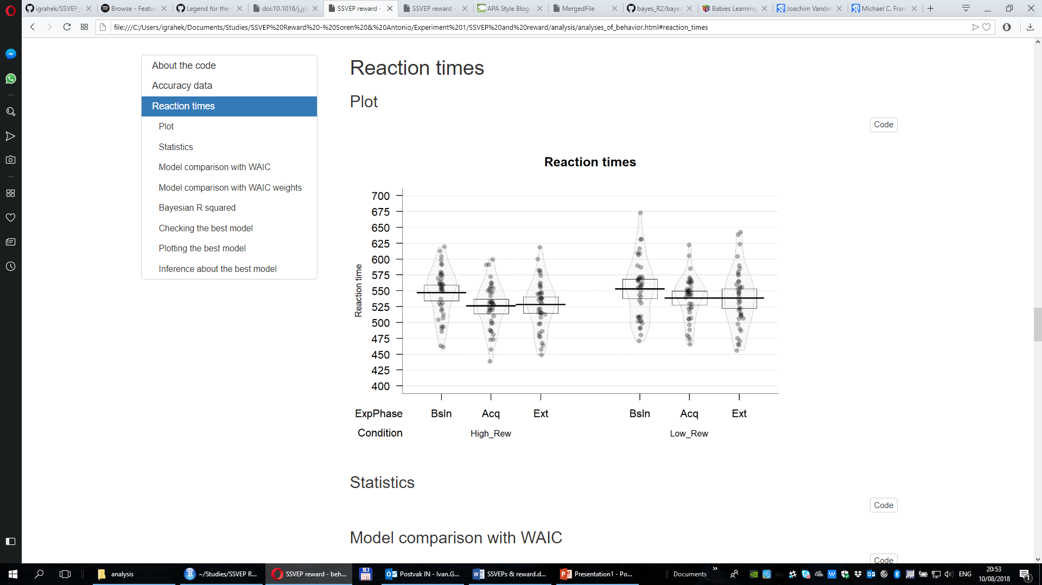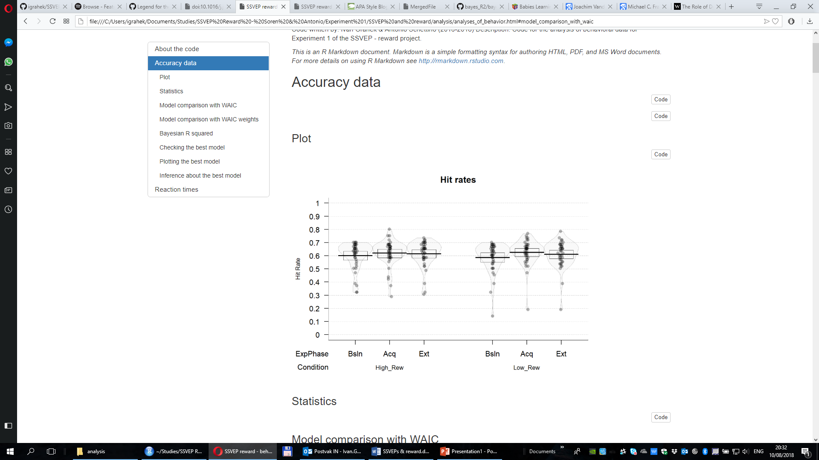

**Figure 3.** Distributions, means, and credible intervals of hit rates and reaction times per condition.

The interaction model best predicted the hit rates (Table 1). This result points to the importance of the interaction between reward phase and reward magnitude in predicting hit rates. The posterior distribution of the interaction model (Figure 4) revealed that hit rates improved in the acquisition phase compared to the baseline. This change was present in both reward magnitude conditions, but more pronounced for low rewarded color. In this condition participants were 999 times more likely to be better in acquisition compared to baseline (*M =* 0.04; 95% HDI [0.02, 0.06]). In the high rewarded condition they were 33 times more likely to better in acquisition compared to baseline (*M =* 0.02; 95% HDI [0.00, 0.04]). The evidence for the difference between the acquisition and the extinction phase was much weaker. Participants were 8 times more likely to be less accurate in the extinction phase compared to the acquisition phase in the low rewarded condition (*M =* -0.01; 95% HDI [-0.04, 0.01]), and 2 times in the high rewarded condition (*M =* -0.01; 95% HDI [-0.03, 0.02]). These results suggest that the participants were reliably more accurate in the acquisition phase compared to baseline, and more so for the low rewarded color. There was also evidence for the drop in their accuracy in the extinction phase for the low rewarded, but not high rewarded color.

|  |  |  |  |  |
| --- | --- | --- | --- | --- |
| Table 1  *Model comparison indices for behavioral results* | | | | |
| Model/Model comparison | | *WAIC (SE)* | *WAIC weight* | *Bayesian R2 (SE)* |
| *Hit rates* | | | | |
| Null | | -475.41 (32.92) | 1.77e-51 | 0.34 (0.05) |
| Reward phase | | -471.65 (33.43) | 2.70e-52 | 0.36 (0.05) |
| Interaction | | -709.13 (23.99) | 1.00 | 0.82 (0.03) |
| *Reaction times* |
| Null | | 2346.29 (32.74) | 2.42e-42 | 0.49 (0.04) |
| Reward phase | | 2329.70 (35.38) | 9.65e-39 | 0.56 (0.04) |
| Interaction | | 2154.64 (25.19) | 1.00 | 0.84 (0.03) |

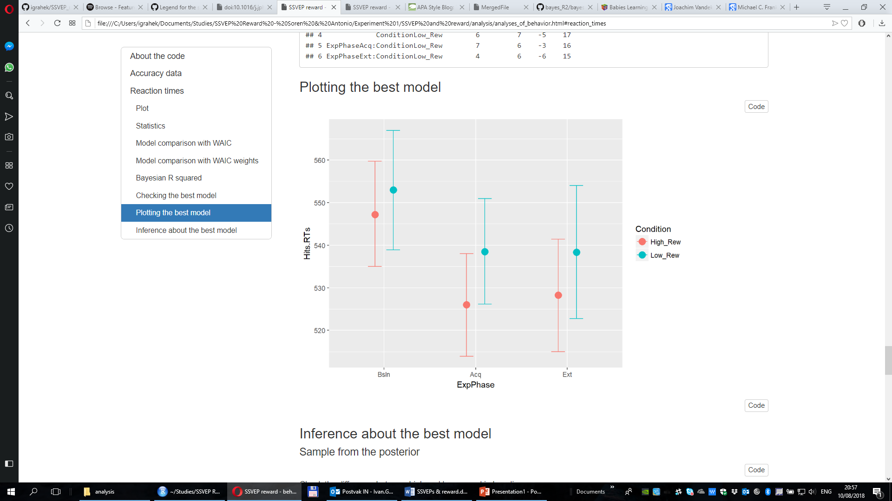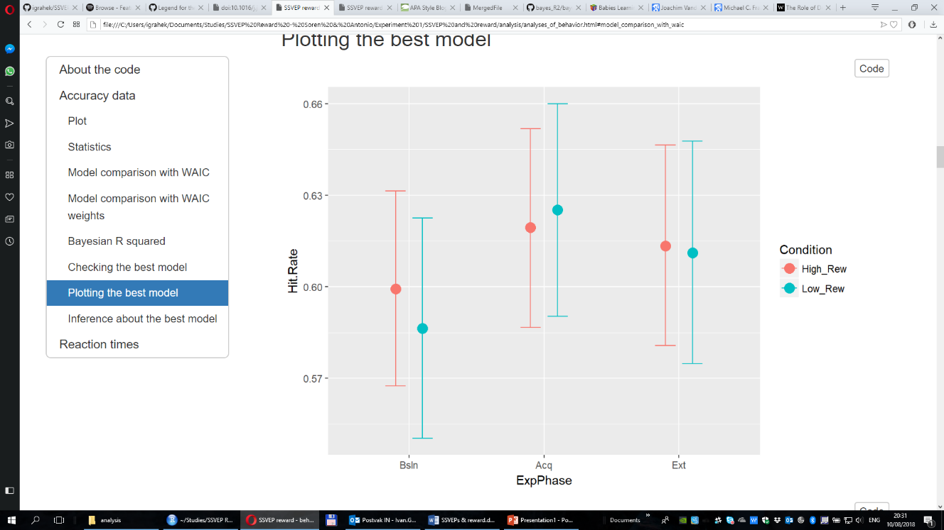

**Figure 4.** Posterior distributions of the interaction models for hit rates and reaction times across conditions.

## Reaction times

The interaction model was also the best one in predicting reaction times (Table 1). Participants were reliably faster in the acquisition compared to the baseline phase. In the high reward condition they were infinitely more likely (full distribution of the difference below 0) to be faster in the acquisition compared to the baseline phase (*M =* -21.2 s; 95% HDI [-29.8, -12.3]). In the low reward condition they were 332 times more likely to be faster in acquisition (*M =* -14.5 s; 95% HDI [-24.7, -4.63]). We found little evidence for the change in reaction times between the acquisition and the extinction phase. For the high reward participants were 2 times more likely to be slower in extinction (*M =* 2.26 s; 95% HDI [-6.8, 11.0]), while for the low condition they were only 1.05 times more likely to be faster in extinction (*M =* -0.15 s; 95% HDI [-10.9, 10.3]). These results indicate that the participants were faster in the condition in which they could earn rewards, and more so in the condition with higher probability of earning a reward. Also, there is no evidence for the change in the reaction times when the rewards were no longer available.

## Training effects

There is a possibility that the improvement in performance from baseline to acquisition is a training effect. In order to investigate this, we have plotted the hit rates and reaction times across every half of the three reward phases (Figure XXX in the supplementary materials). These plots show no improved performance during the baseline phase, and the improved performance from the beginning of the acquisition phase.

## SSVEP amplitudes

Raw data – always plot in the same fashion as the posterior

Evidence that the winning model converged (just trace plots for fixed effects) bayesplot package for the trace plots (Antonio’s e-mail)

1. Model comparison

Mention in text the WAIC difference with SE for the comparison between the interaction and the second best model.

|  |  |  |  |
| --- | --- | --- | --- |
| Table 2  *Model comparison indices for EEG results* | | | |
| Model/Model comparison | *WAIC (SE)* | *WAIC weight* | *Bayesian R2 (SE)* |
| Null | -122.16 (38.14) | 1.79e-39 | 0.00 (0.00) |
| Reward phase | -115.47 (38.14) | 6.32e-41 | 0.02 (0.01) |
| Attention | -211.10 (41.72) | 3.68e-20 | 0.21 (0.04) |
| Reward phase and attention | -200.35 (41.10) | 1.71e-22 | 0.22 (0.04) |
| Reward magnitude X reward phase + attention | -272.18 (42.75) | 6.74e-07 | 0.43 (0.04) |
| Interaction | -300.60 (40.58) | 1.00 | 0.53 (0.05) |
|  | | | |

1. The winning model:
   1. Plot – pirate, but only with the distribution and maybe with the CrI
   2. Posterior predictive checks (pp_check, stat_grouped plot for every condition for the winning model)
   3. Bayes R2 (put it in a table for all models: WAIC, WAIC weights, and bayes R2)
   4. Inference
      1. Probability (in percent) that there is a difference
      2. Evidence ratios for comparing different conditions

# Discussion

*1500 word limit including citations*

## Software for data visualization and analysis

Visualization and statistical analyses were performed using R v3.4.4 via RStudio v1.1.453. We used the following packages (and their respective dependencies):

• data manipulation: tidyverse v1.2.1;

• statistical analyses: Rmisc v1.5, brms v2.3.1;

• visualization: cowplot v0.9.2, yarrr v0.1.5, viridis v0.5.1, eegUtils v0.2.0, brmstools, BEST;

• report generation: pacman v0.4.6, knitr v1.20.

# Acknowledgements

This work was supported by the Special Research Fund (BOF) of Ghent University [grant #01D02415 awarded to IG; grant # BOF14/PDO/123 awarded to AS] and the Concerted Research Action Grant of Ghent University [grant number BOF16/GOA/017 awarded to EHWK]. Add funding for Gilles and Søren. The funding sources had no involvement in the study design; collection, analysis, and interpretation of data; writing of the report; and decision to submit the article for publication.

We would like to thank Dr. Inez Greven for help with data collection.

# Author contributions

IG, AS, and SKA conceived the study. SKA and IG programmed the experimental paradigm. SKA, GP, and EHWK contributed reagents/materials/tools. IG collected the data, supervised by AS. IG and AS analyzed the data. IG and AS wrote the main manuscript text. IG, AS, GP, EHWK, and SKA reviewed and critically revised the manuscript.

# Data availability

Raw and pre-processed data, materials, and analysis scripts are available at <https://osf.io/xxxxx/>.

# References

Andersen, S. K., & Müller, M. M. (2010). Behavioral performance follows the time course of neural facilitation and suppression during cued shifts of feature-selective attention. *Proceedings of the National Academy of Sciences of the United States of America*, *107*(31), 13878–13882. https://doi.org/10.1073/pnas.1002436107

Andersen, S. K., Müller, M. M., & Hillyard, S. A. (2012). Tracking the allocation of attention in visual scenes with steady-state evoked potentials. In *Cognitive neuroscience of attention* (pp. 197–216).

Anderson, B. A. (2016). The attention habit: How reward learning shapes attentional selection. *Annals of the New York Academy of Sciences*, *1369*(1), 24–39. https://doi.org/10.1111/nyas.12957

Bürkner, P.-C. (2016). brms: An R package for Bayesian multilevel models using Stan. *Journal of Statistical Software*, *80*(1), 1–28.

Carpenter, B., Gelman, A., Hoffman, M., Lee, D., Goodrich, B., Betancourt, M., … Riddell, A. (2016). Stan: A probabilistic programming language. *Journal of Statistical Software*, *2*(20), 1–37.

Chelazzi, L., Perlato, A., Santandrea, E., & Della Libera, C. (2013). Rewards teach visual selective attention. *Vision Research*, *85*, 58–62. https://doi.org/10.1016/j.visres.2012.12.005

Chun, M. M., Golomb, J. D., & Turk-Browne, N. B. (2011). A Taxonomy of External and Internal Attention. *Annual Review of Psychology*, *62*(1), 73–101. https://doi.org/10.1146/annurev.psych.093008.100427

Della Libera, C., & Chelazzi, L. (2009). Learning to attend and to ignore is a matter of gains and losses. *Psychological Science*, *20*(6), 778–784. https://doi.org/10.1111/j.1467-9280.2009.02360.x

Desimone, R., & Duncan, J. (1995). Neural Mechanisms of Selective Visual. *Annual Review of Neuroscience*, *18*(1), 193–222. https://doi.org/10.1146/annurev.ne.18.030195.001205

Failing, M., & Theeuwes, J. (2017). Selection history: How reward modulates selectivity of visual attention. *Psychonomic Bulletin and Review*, 1–25. https://doi.org/10.3758/s13423-017-1380-y

Franken, I. H. A., Muris, P., & Rassin, E. (2005). Psychometric properties of the Dutch BIS/BAS scales. *Journal of Psychopathology and Behavioral Assessment*, *27*(1), 25–30. https://doi.org/10.1007/s10862-005-3262-2

Gelman, A., Goodrich, B., Gabry, J., & Ali, I. (2017). R-squared for Bayesian regression models. *Unpublished via Http://Www. Stat. Columbia. Edu/~ Gelman/Research/Unpublished.* Retrieved from http://www.stat.columbia.edu/~gelman/research/unpublished/bayes_R2.pdf

Gelman, A., & Rubin, D. B. (1992). Inference from Iterative Simulation Using Multiple Sequences. *Statistical Science*, *7*(4), 457–472. https://doi.org/10.1214/ss/1177011136

Kruschke, J. K. (2014). *Doing Bayesian data analysis: A tutorial with R, JAGS, and Stan, second edition*. *Doing Bayesian Data Analysis: A Tutorial with R, JAGS, and Stan, Second Edition* (2nd ed.). Elsevier Inc. https://doi.org/10.1016/B978-0-12-405888-0.09999-2

Maunsell, J. H. R. (2004). Neuronal representations of cognitive state: Reward or attention? *Trends in Cognitive Sciences*, *8*(6), 261–265. https://doi.org/10.1016/j.tics.2004.04.003

Muller, M. M., Andersen, S., Trujillo, N. J., Valdes-Sosa, P., Malinowski, P., & Hillyard, S. A. (2006). Feature-selective attention enhances color signals in early visual areas of the human brain. *Proceedings of the National Academy of Sciences*, *103*(38), 14250–14254. https://doi.org/10.1073/pnas.0606668103

Norcia, A. M., Appelbaum, L. G., Ales, J. M., Cottereau, B. R., & Rossion, B. (2015). The steady-state visual evoked potential in vision research : A review. *Journal of Vision*, *15*(6), 1–46. https://doi.org/10.1167/15.6.4.doi

Roelfsema, P. R., van Ooyen, A., & Watanabe, T. (2010). Perceptual learning rules based on reinforcers and attention. *Trends in Cognitive Sciences*, *14*(2), 64–71. https://doi.org/10.1016/j.tics.2009.11.005

Van der Does, A. J. W. (2002). *Handleiding bij de Nederlandse versie van beck depression inventory—second edition (BDI-II-NL). [The Dutch version of the Beck depression inventory].* Amsterdam: Harcourt.

Watanabe, S. (2010). Asymptotic Equivalence of Bayes Cross Validation and Widely Applicable Information Criterion in Singular Learning Theory, *11*, 3571–3594. Retrieved from http://arxiv.org/abs/1004.2316